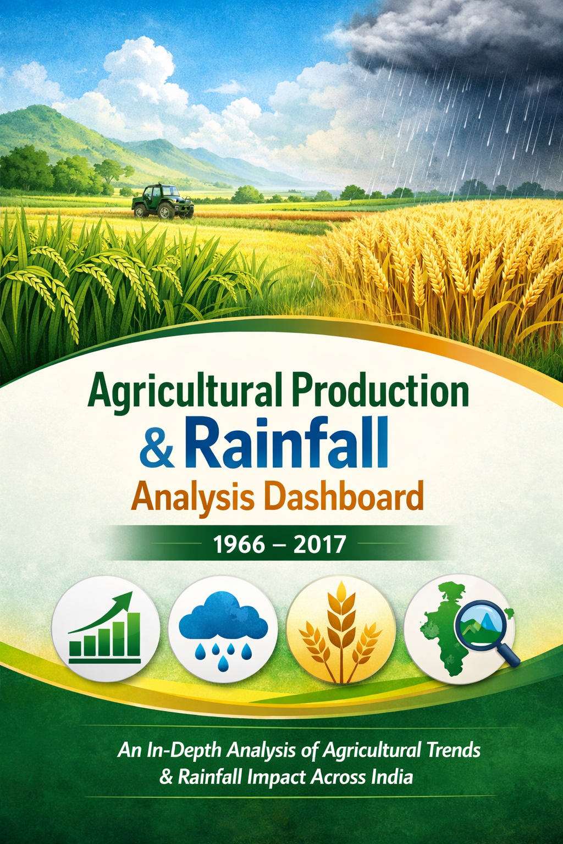
🌾 Agricultural Production & Rainfall Analysis Dashboard (1966–2017)

📌 Project Overview
This Power BI dashboard analyses historical agricultural production and rainfall data across Indian states (1966–2017).
Objective: Identify production trends, evaluate rainfall impact on crop productivity, compare state-wise performance, and provide actionable insights for data-driven decision-making.

🛠️ Data Cleaning & Preparation
Performed using Power Query Editor before dashboard creation.
- Removed duplicates
- Handled missing/null values
- Corrected inconsistent data types
- Renamed columns for readability
- Removed unnecessary fields
- Standardized state & crop names
Data Model:
- Dimension Tables → Calendar, Crop, State, Season
- Fact Table → Linked via Star Schema for optimized performance

📊 Measures Created (DAX)
Rainfall Metrics
- Total Rainfall
- Average Rainfall
Production Metrics
- Total Production
- Production per Area
- Rainfall per Production
Yield Metrics
- Average Yield
- Maximum & Minimum Yield
- Average Rice Yield
- Average Wheat Yield
Area Metrics
- Total Cultivated Area
Crop-specific Metrics
- Total Rice Production
- Total Wheat Production
Efficiency Metric
- Yield Efficiency

📑 Dashboard Pages
- Executive Dashboard
  - KPIs: Rainfall, Production, Yield, Area, Efficiency
  - Rainfall Trend (1966–2017)
  - Crop-wise Production Analysis (Treemap)
- Crop Analysis
  - Rainfall & Yield Trends
  - Rainfall vs Production Comparison
  - Crop-wise Avg Rainfall vs Avg Yield
- State Analysis
  - Filled Map Visualization
  - State-wise Production Ranking & Yield
- Rainfall Impact Analysis
  - Rainfall vs Yield Scatter Plot
  - Rainfall vs Production Comparison
- Insights & Recommendations
  - Key findings
  - Practical recommendations

🔍 Key Insights
- Total rainfall (1966–2017): 25.45 million mm (avg. 938 mm annually) → stable rainfall patterns.
- Total agricultural production: 704k+ units → consistent long-term growth.
- Rice & Wheat → leading contributors.
- Punjab, Haryana, Andhra Pradesh, Tamil Nadu → consistently high productivity.
- Rainfall influences production, but irrigation, technology, and farming practices are equally critical.

✅ Recommendations
- Adopt modern irrigation systems to reduce monsoon dependency.
- Promote region-specific high-yield crop varieties.
- Replicate successful practices from high-performing states.
- Strengthen rainfall monitoring & forecasting.
- Invest in precision farming & sustainable technologies.
- Use BI dashboards for evidence-based policy planning.

📌 Conclusion
The dashboard provides a comprehensive decision-support tool by transforming historical agricultural data into actionable insights. While rainfall remains a key driver, resource management, technology adoption, and modern farming practices are equally vital for sustainable agricultural development.

